Installing HSyE SPC Software (Excel) on Virtual Desktop

Introduction
Hello! My name is Shane Yap and I’m so excited for you to try this software that I helped build over the past few years. It is still very rudimentary and in beta testing but I would love for you to test it out so I can collect valuable usage data! Currently it ONLY works on Windows and NOT on Macs, so please follow the instructions below on how to use this software using Northeastern’s Virtual Desktop.

Step 1: Getting onto Virtual Desktop (If you are a Windows user, skip to Step 2)
- Navigate to the virtual desktop website: https://rdweb.wvd.microsoft.com/webclient/index.html
- Choose “Student VDI”
- Allow access to your local resources when prompted.
- Login using your northeastern credentials when prompted.
- At this point, it might take awhile to load/setup depending on traffic usage and if its your first time. Be patient!
- Once you see the regular windows desktop, you have successfully connected to the virtual desktop and ready to start.
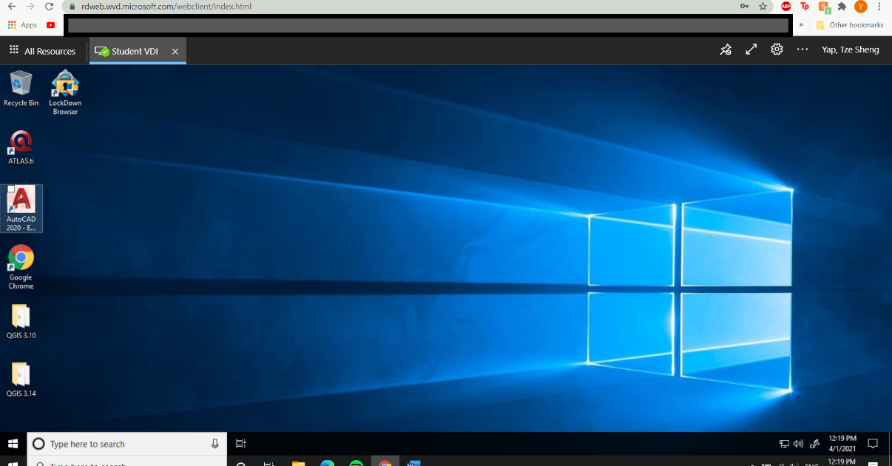

Step 2: Downloading the SPC Software
- (For MAC Users, everything from this point forward is to be done WITHIN the virtual desktop)
- Navigate to our tools page: https://www.hsye.org/covid-19-statistical-monitoring
- Download the “General Purpose Control Chart Tool” (IMPORTANT!!! Do not unzip/open the downloaded file – please move on to Step 3)
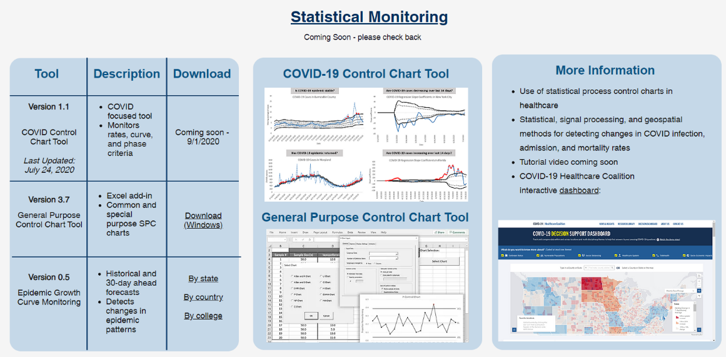

Step 3: Installing the SPC Software
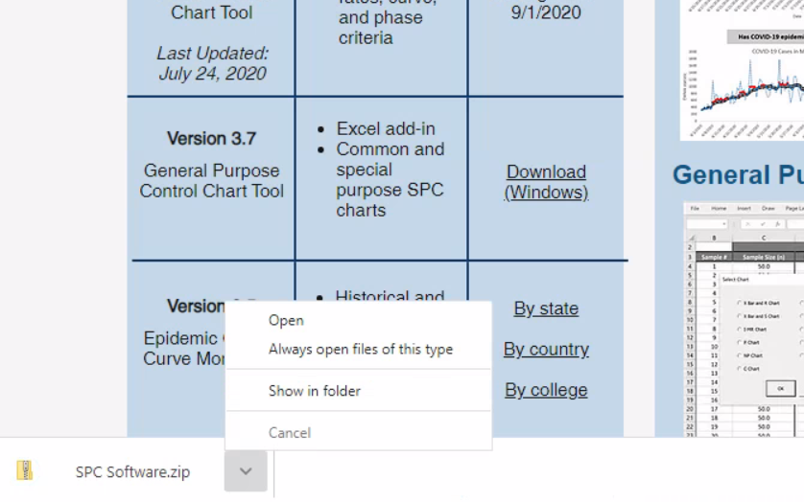
- Navigate to the folder where you just downloaded the SPC Software ZIP File (Most likely it will be in your “Downloads” Folder)
- Right-click on the SPC Software Zip File and click “Properties”. 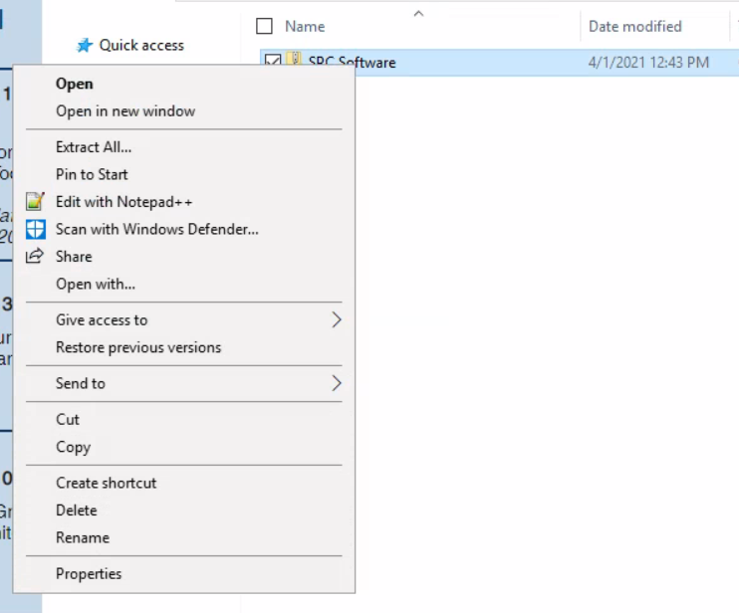
- At the bottom right of the Properties page, check “Unblock” then click OK. 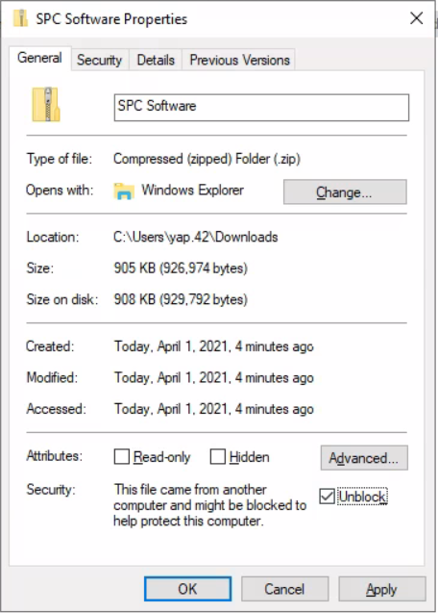
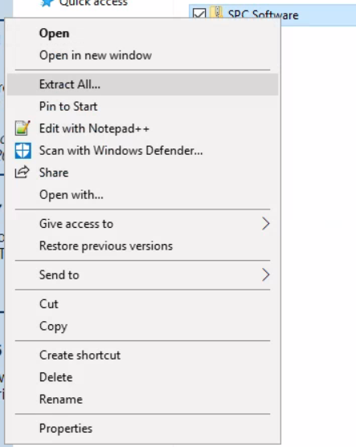
- Right-click on the ZIP file again and click “Extract All…”
- The default folder that it will be extracted to should be the same “Downloads” Folder – if not, hit “Browse” and change it to that to reduce any trust issues with the software. 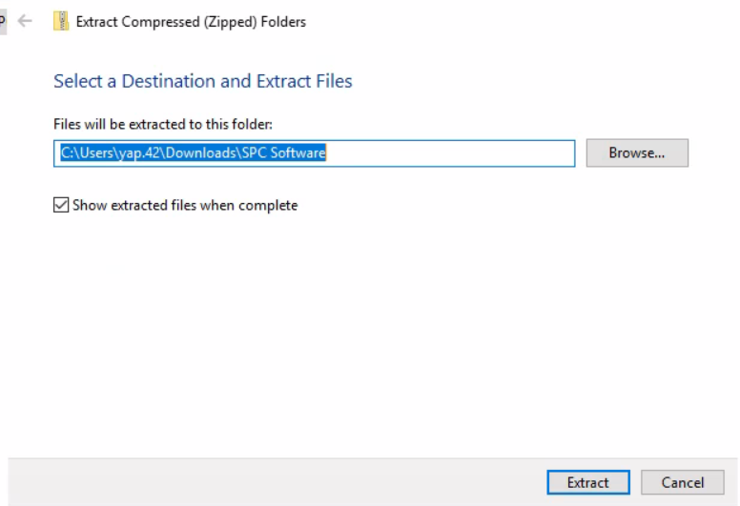
- Hit “Extract”.
- Once that is done, open the extracted “SPC Software” Folder, NOT the ZIP file.
- Open the “SPC Toolbar V2” folder.
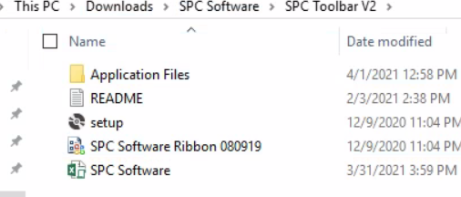
- At this point, you should see 5 files. Open the “SPC Software” Excel File:
- If you are prompted to activate your Microsoft Office, just hit “Close” 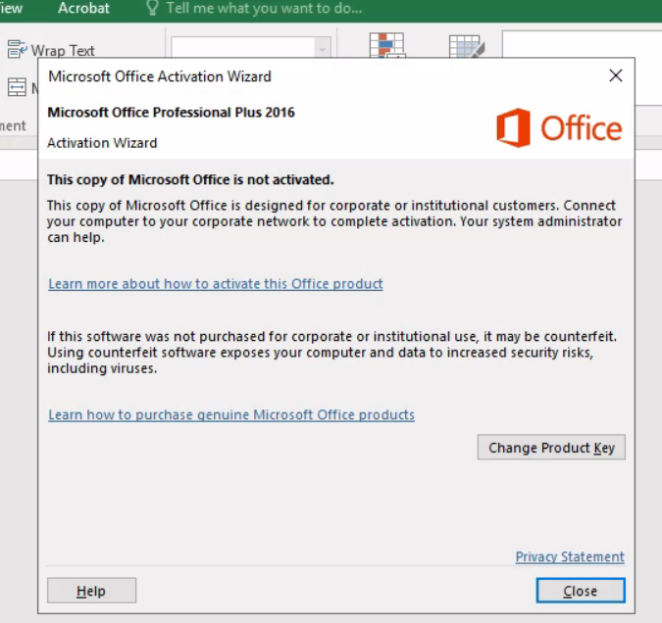
- When prompted to Install the ribbon customization, hit “Install” 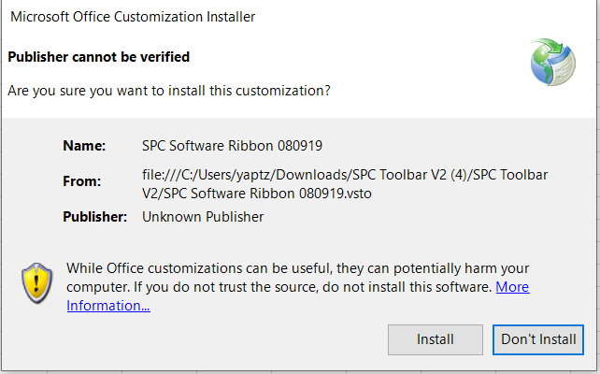
- If prompted to enable content and macros, hit “Enable” 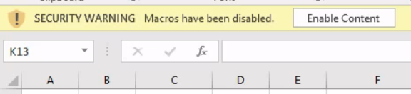
- If everything was done correctly, you have successfully installed the software! There should be a tab on the top toolbar of the Excel file called “SPC Charts”. 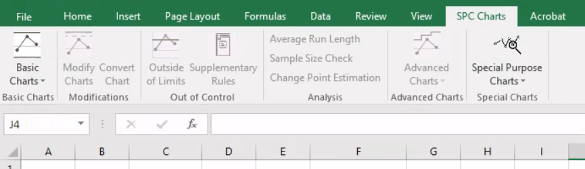
- You are now ready to use the software to create SPC Charts!!!

Troubleshooting & Tips
- Please create extra copies of the excel file in case something goes wrong. If you run into an error and somehow expose the VBA code (this shouldn’t happen but if it does) just close out of the entire excel file without saving and reopen it. If you are somewhat versed in VBA, just stop the code from running and exit out of the code window.
- Since this is still in BETA testing, not all functionalities might work 100%. However, the functionalities needed to complete the assigned questions do work 100%. Feel free to play around with it (not too much or else it might break hahaha)
- If you run into installation issues such as “this file must be opened from a trusted location, save it and open it from a trusted location” or something along those lines, then please move the zip folder and extracted folder onto a trusted location of your computer (the “Downloads” folder works perfectly on the Virtual Desktop), then try running the Excel file again.

Contact & End Notes
And that is it! Please try it out and fill out the google feedback form so I can continue to improve the software and make it as user-friendly as possible (Prof. Martinez should have sent you the link – if not here it is: https://docs.google.com/forms/d/e/1FAIpQLSe5N-ilfrWFMxMok3wiPtWL09T0wPrTf-tZ0HUVUfzMAq2NbA/viewform?usp=sf_link
Also, feel free to reach out to me via email (yap.42@northeastern.edu) if you have any specific questions regarding the software, answering the bonus assignment questions, or if you are interested in learning more/getting involved! Thank you again.

